

EDC Study Portal
Site Guide
Getting Started

Home
After logging into EDC Study Portal, you will land on the Home page:
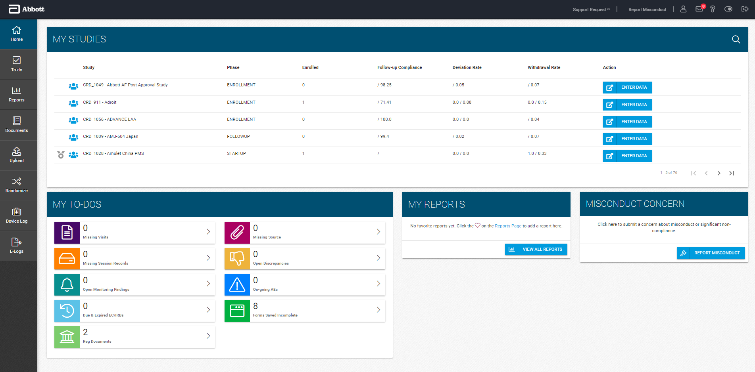
4
3
2
1
On the Home page there are 4 sections:
- My Studies – Overview of all your studies and ability to launch RDC to enter study data.
- My To-Dos – Categorized tasks for your studies with the ability to launch the To Do menu to view pertinent details.
- My Reports – Ability to view and run your favorite reports or view all available reports.
- Misconduct Concern – Ability to report a misconduct or compliance concern.

My Studies
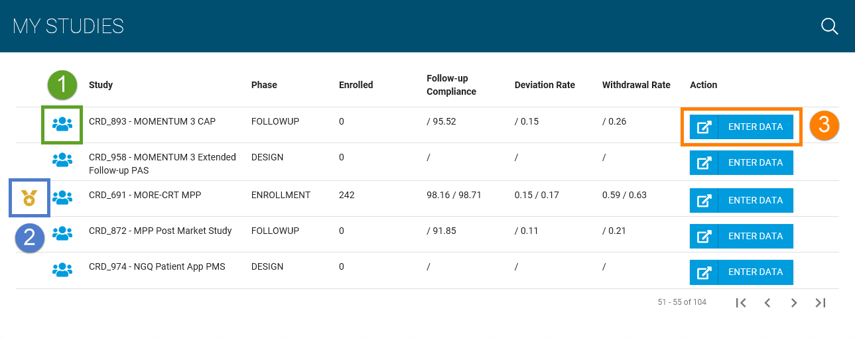
- Click this icon to view the Abbott contacts for a study
- A medal indicates your site is one of the top enrollers for a study
-  Click this button to launch RDC for a study

My To-Dos
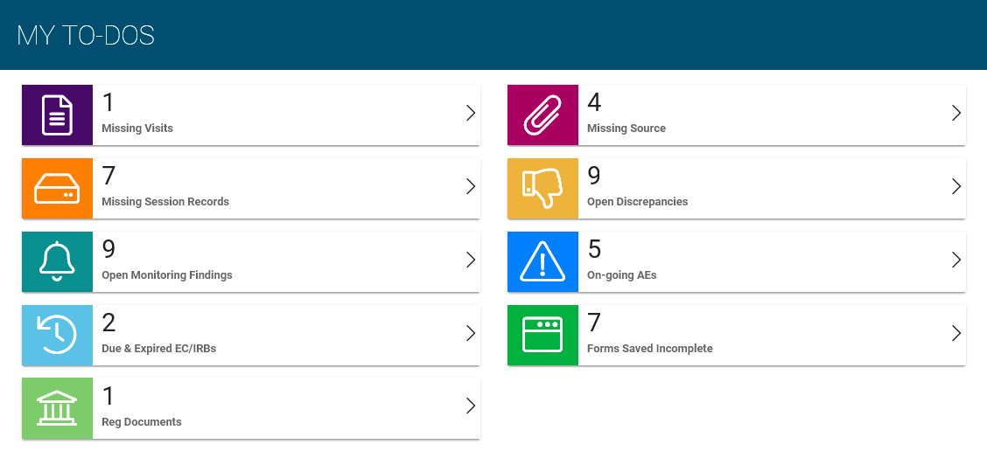
- The number indicated on each To Do category is the total for all your studies.
- You can view a breakdown of each To Do item by individual study if you hover your mouse over one of the categories.

My Reports
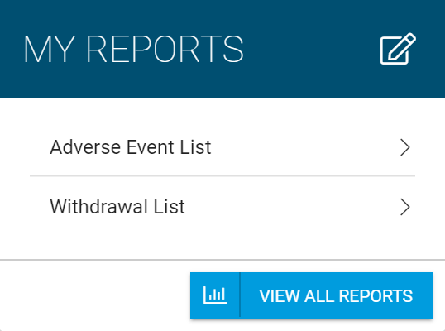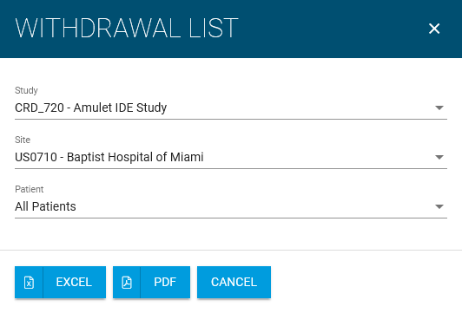

- You can open a report directly from My Reports by clicking on the report.
- Another menu will pop up for you to run the report.

Misconduct Concern
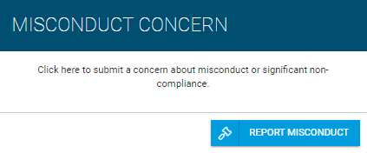

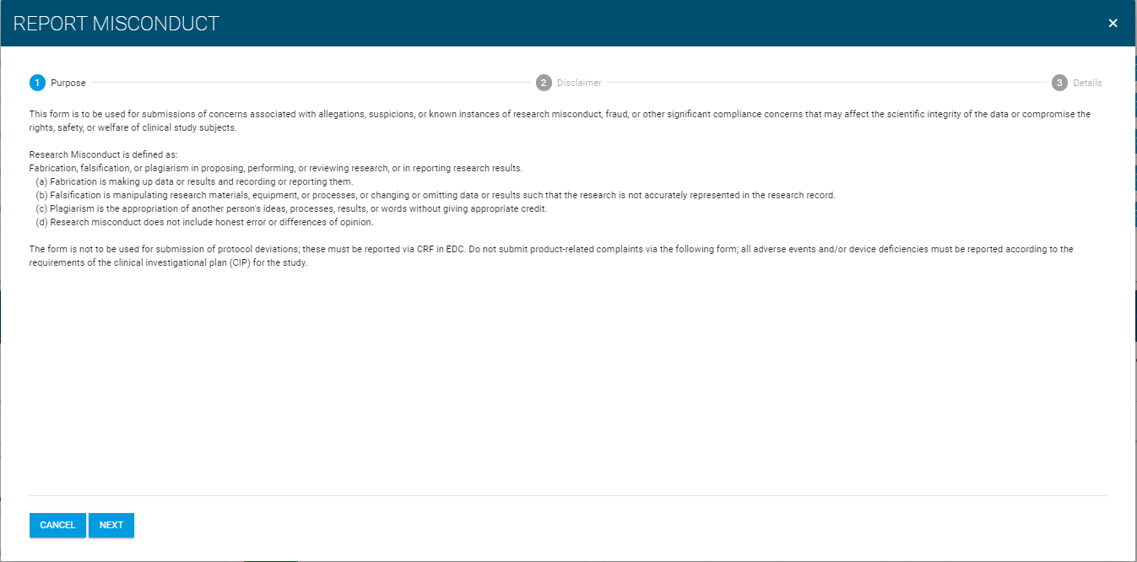
- You can submit a concern by clicking on the REPORT MISCONDUCT button.
- A wizard will pop up for you to submit your concern electronically or, alternatively, to provide you with an Abbott contact to reach out by phone.

Home
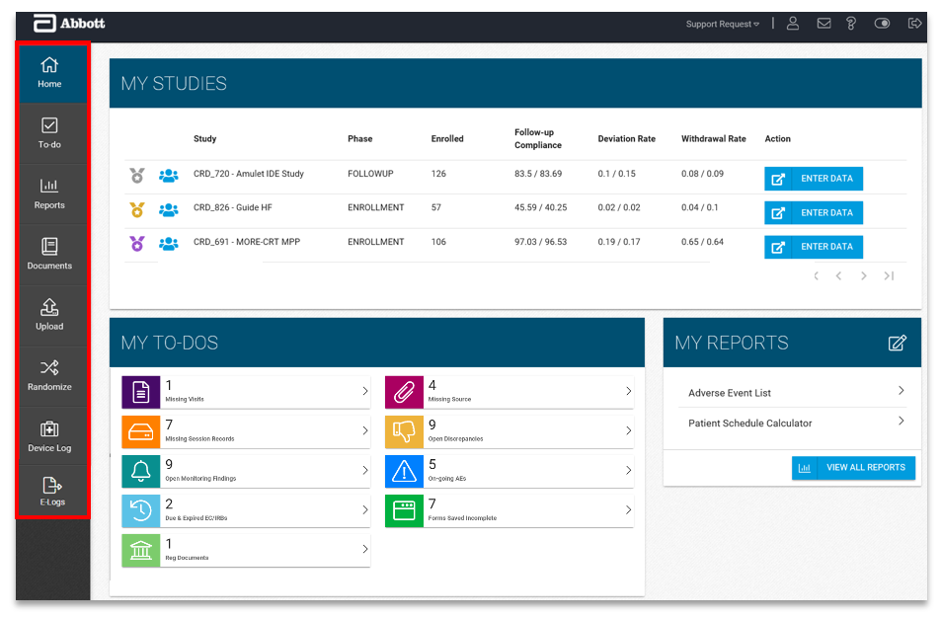
On the left-hand menu are links to pages:
- Home – Main page you’ll see after logging in, which has general study information
- To-do – View details about outstanding tasks for your studies
- Reports – List of reports you can run for your studies
- Documents – View or upload regulatory documents, view study related documents, and view any study site communications
- Upload – Upload source documents or device session data (as applicable) and view upload history
- Randomize* – If one of your studies has randomization, you can access it from the menu
- Device Log* – If one of your studies utilizes the Device Log, you can access it from the menu
- E-Logs* - If one of your studies utilizes an Electronic Log, you can access it from the menu
Top Toolbar Menu
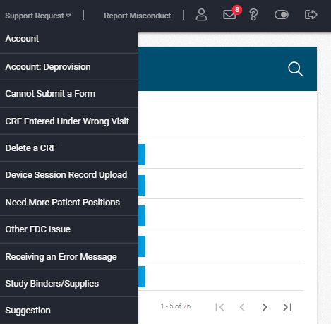
From the Top Toolbar Menu you can select:
- Support Request – Create a support request for one of the listed reasons
- Report Misconduct – use an electronic form to report a concern about misconduct or compliance issue or, alternatively, find Abbott contact details
- My Info – View and edit your contact information
- Announcements – View pertinent study/site announcements
- Help – Resources if you are having technical issues and phone numbers for the EDC Support Line
- Toggle Menu – Hides or shows the left-hand menu
- Logout – Exit EDC Study Portal

My Contact Info
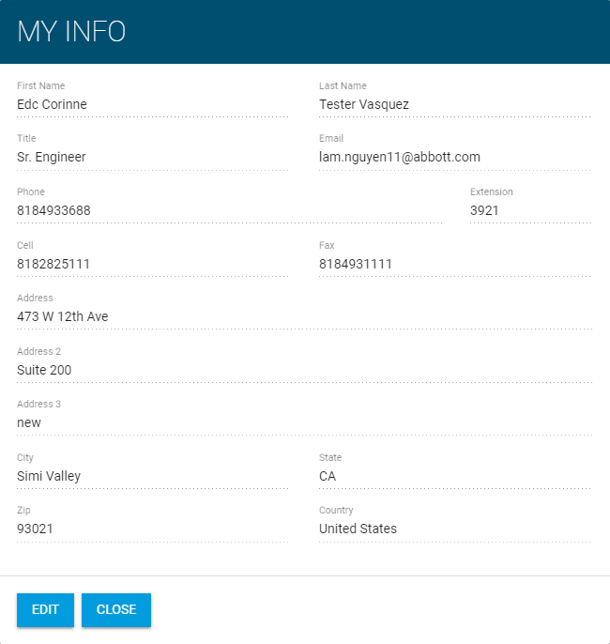
On My Contact Info you’ll see your contact information that is in the system.
You can click ‘Edit’ to make corrections to your contact information.

Announcements
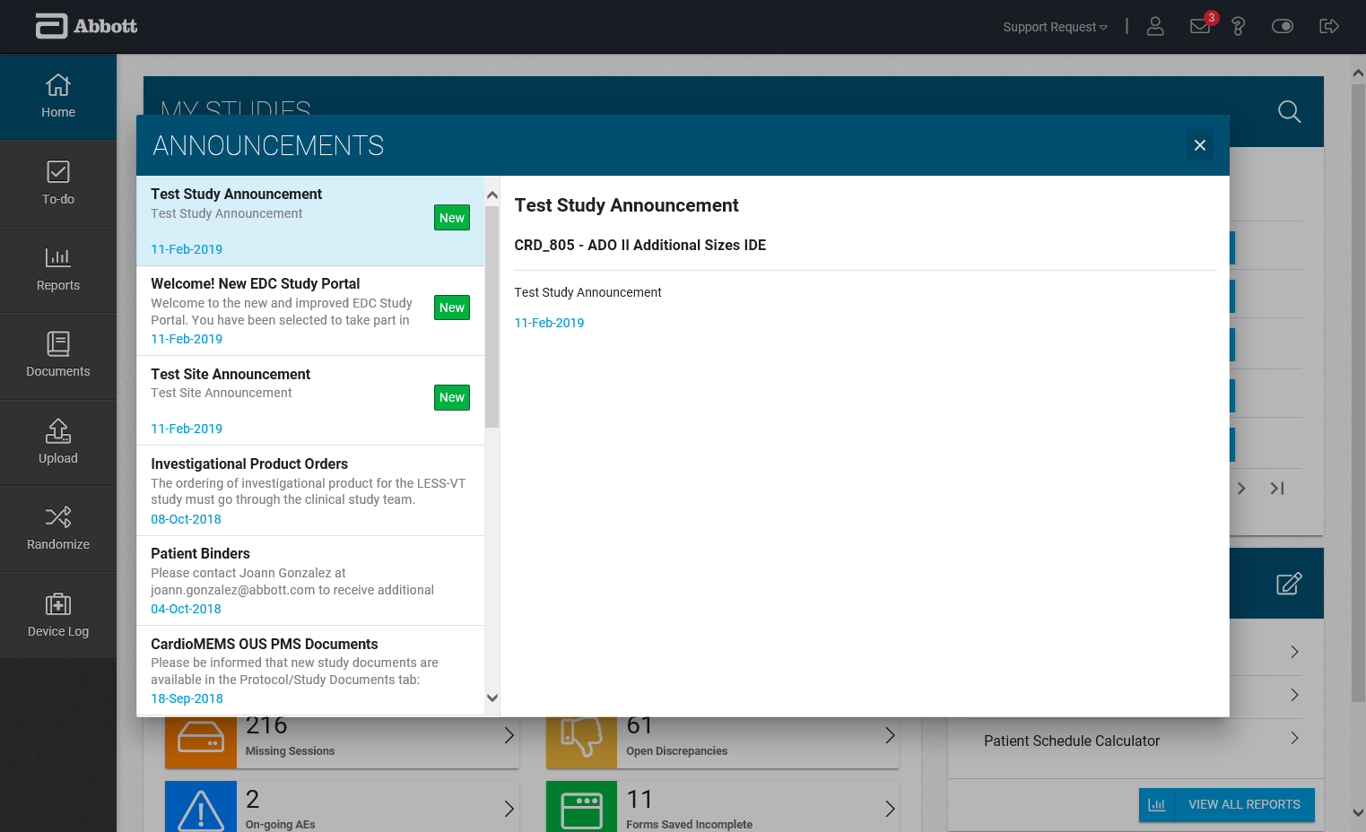
On Announcements you will see all study and site-specific announcements:
- New announcements are indicated by a highlighted red number on the announcements icon.
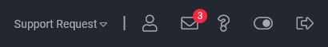
- When opening to view the announcement details, new announcements will have a green tag indicating new next to the message.
- All previous announcements will also be listed in chronological order.

Help – EDC Support Phone Line
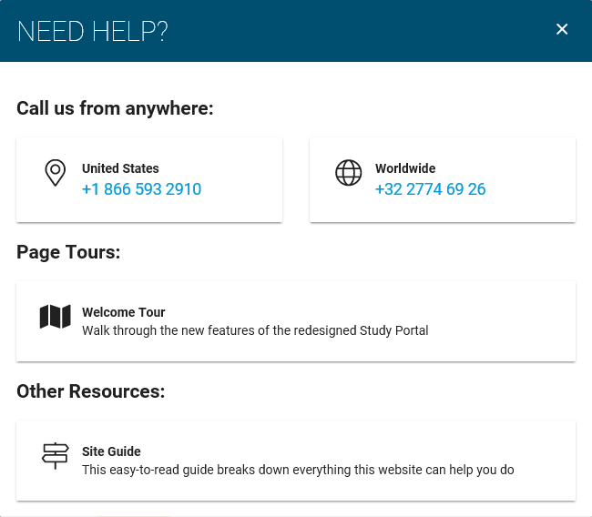
On Help there are resources if you require assistance while using the EDC Study Portal.
- If you encounter any technical issues, there are phone numbers listed for the EDC Support Line.
- Page tours are provided to give you a visual guide on how to navigate the EDC Study Portal.
- Site Guide will open a help document with more detailed information about the EDC Study Portal.

To-do
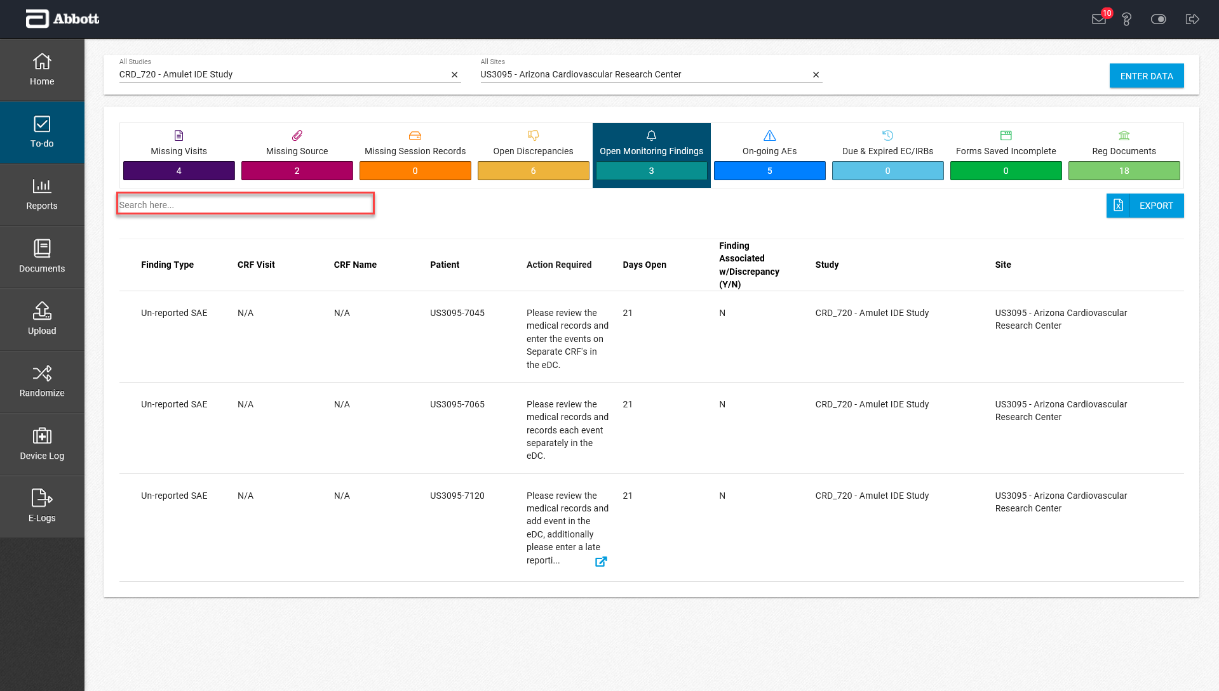
The To-do page will list and provide details for any outstanding tasks you may have for a study.
To-do items are split into different categories:
- Missing Forms
- Missing Source
- Missing Sessions
- Open Discrepancies
- Open Monitoring Findings
- On-going AEs
- Due & Expired EC/IRBs
- Forms Saved Incomplete
- Reg Documents
To-do items can be displayed for all your studies or only a specific study.
*Using the Search here… box you can search for a specific patient, form, or visit. There is also an option to export To-do items to an excel spreadsheet.
Reports
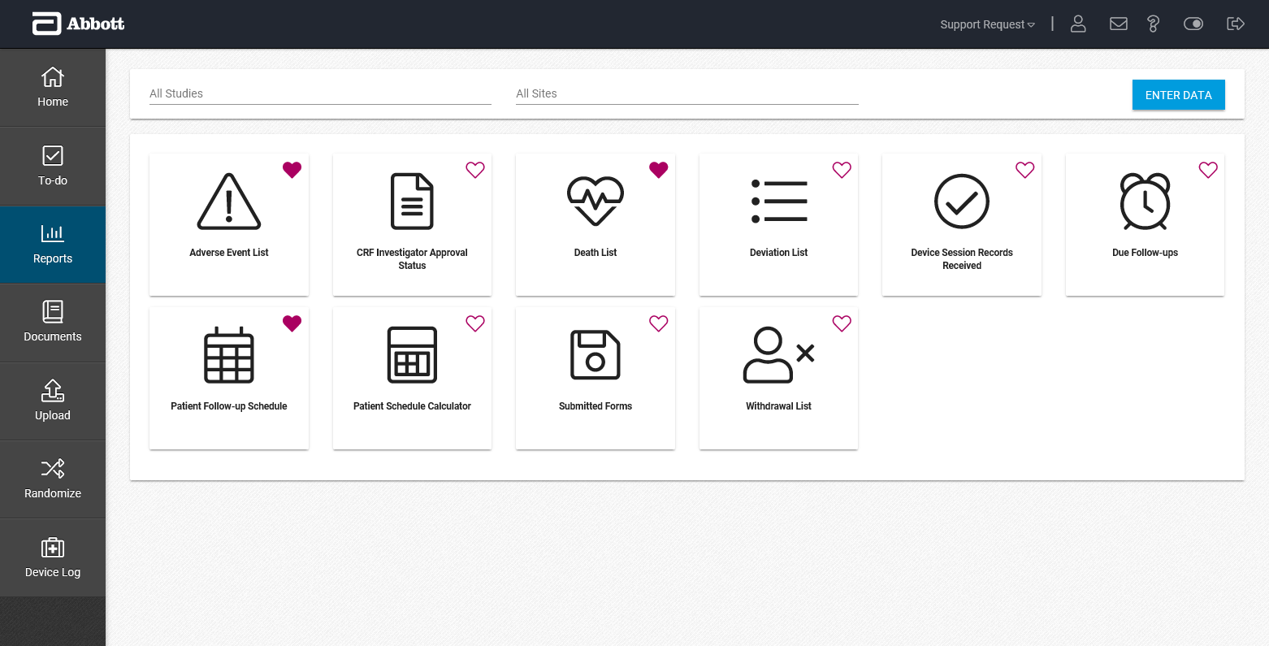
The Reports page will list all the reports available:
- Adverse Event List
- CRF Investigator Approval Status
- Death List
- Deviation List
- Device Session Records Received
- Due Follow-ups
- Patient Follow-up Schedule
- Patient Schedule Calculator
- Submitted Forms
- Withdrawal List
Any report not applicable to your study will be greyed out and not selectable.
By clicking on the heart, you can favorite a report and it will be added to the My Reports section on the Home page.

Documents
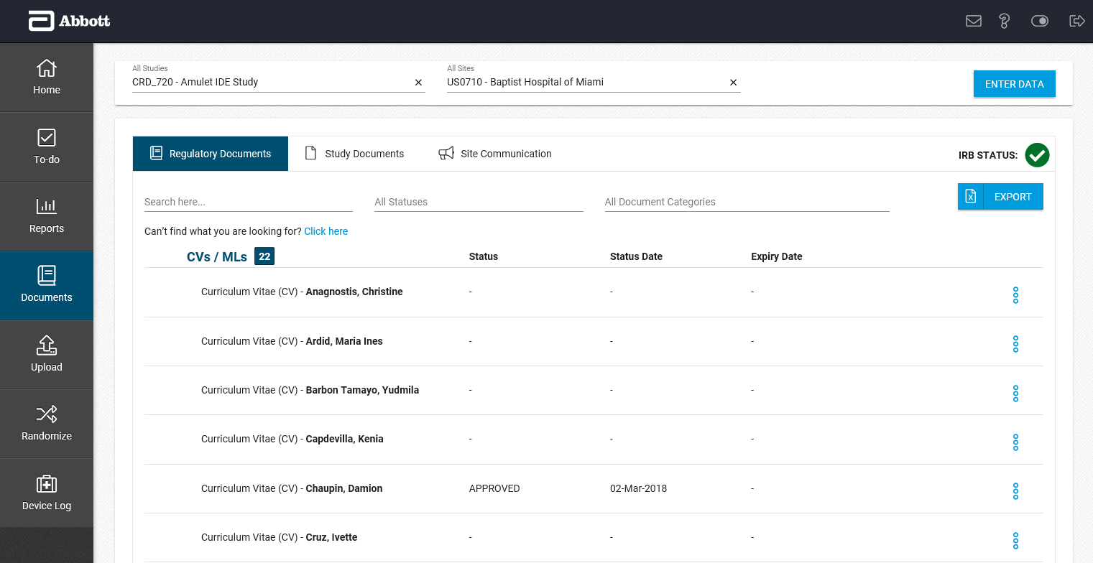
The Documents page has 3 tabs:
- Regulatory Documents – Lists historical details about regulatory documents and its associated status related to your study site. You can upload and download documents from here.
  - IRB Status – If your site uses an IRB it’s status will display in the top right
    -  Expires in more than 60 days
    -  Expires in 60 days or less
    -  Expired
- Study Documents – Lists protocol related documents, tools, and FAQs for your study
- Site Communication – Lists announcements, newsletters, and memos for your study

Upload – Source or Session Records (as applicable)
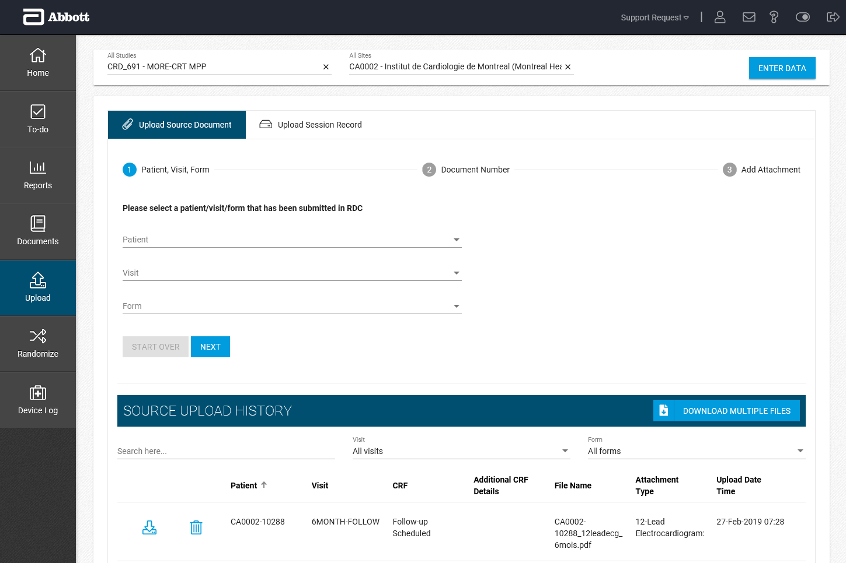
On the Upload page you can upload source documents or session records (as applicable) for a patient:
- All source documents and session records that you have uploaded will be listed.
- You can delete or download any source documents you have uploaded.

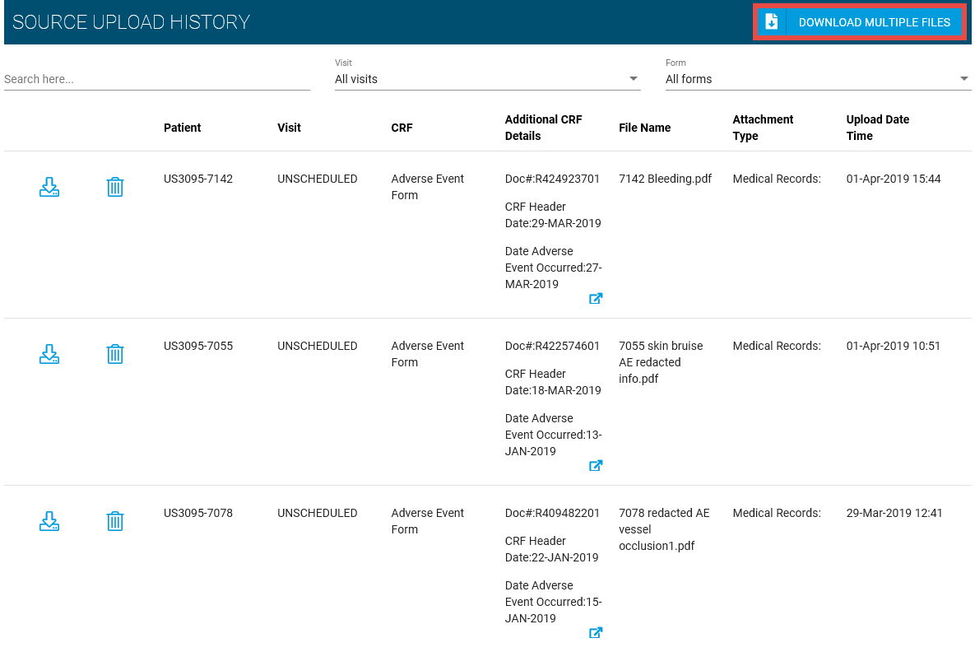
To download multiple source documents, select the Download Multiple Files button.

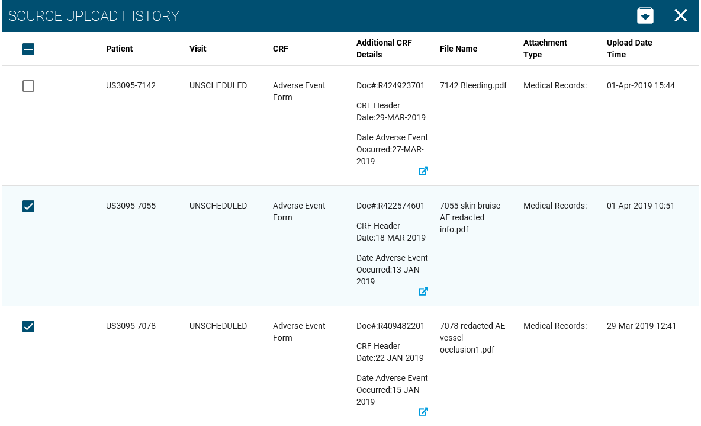
Select the checkboxes next to the source documents you wish to download.
Click to download the selected source documents
Click to cancel multiple file selection

Randomize
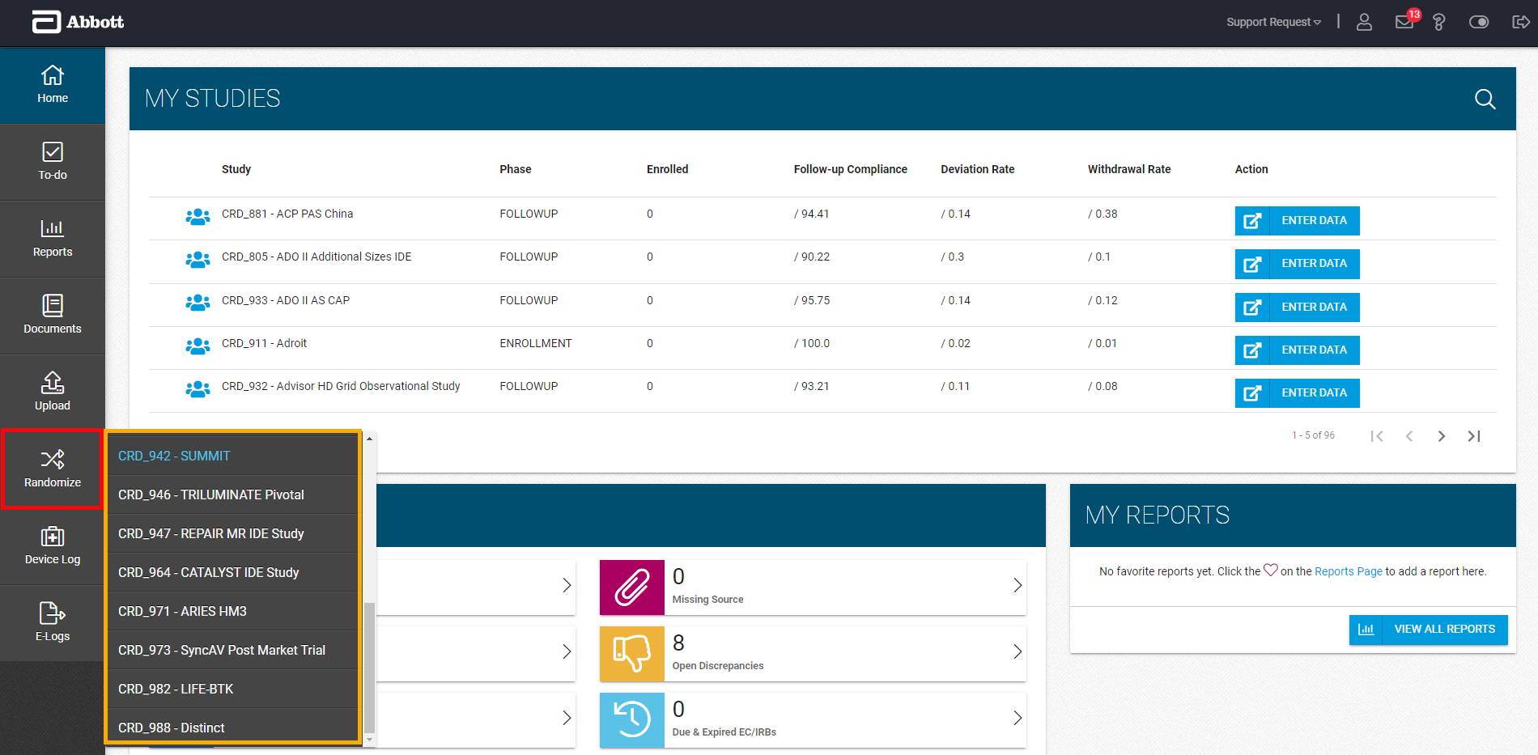
The Randomize menu will launch the Randomization application based on the study you select in the pop-out.

Device Log
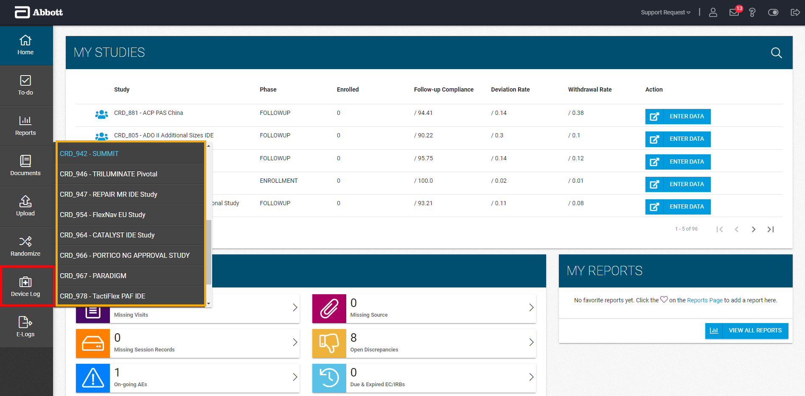
The Device Log menu will launch the Electronic Device Accountability (eDA) Log application based on the study you select in the pop-out.
Note: The availability of a study for selection does not guarantee use of the Log. This log is only used for products that are investigational in your country.
In this application, you can:
- Confirm receipt of shipments by clicking Yes in the Confirm column*
- Capture accidental disposal of devices by clicking the Disposed checkbox and entering required information*
- Generate an auditable Device Accountability Log
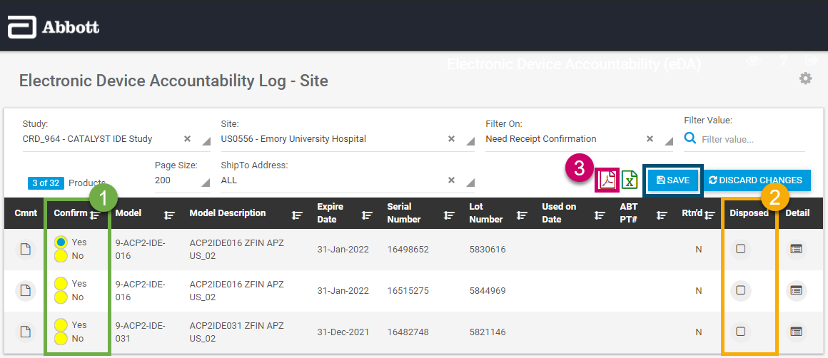
- Document a product return by clicking on the checkbox in the Rtn’d column and entering the Date Sent and Tracking information for the products sent*
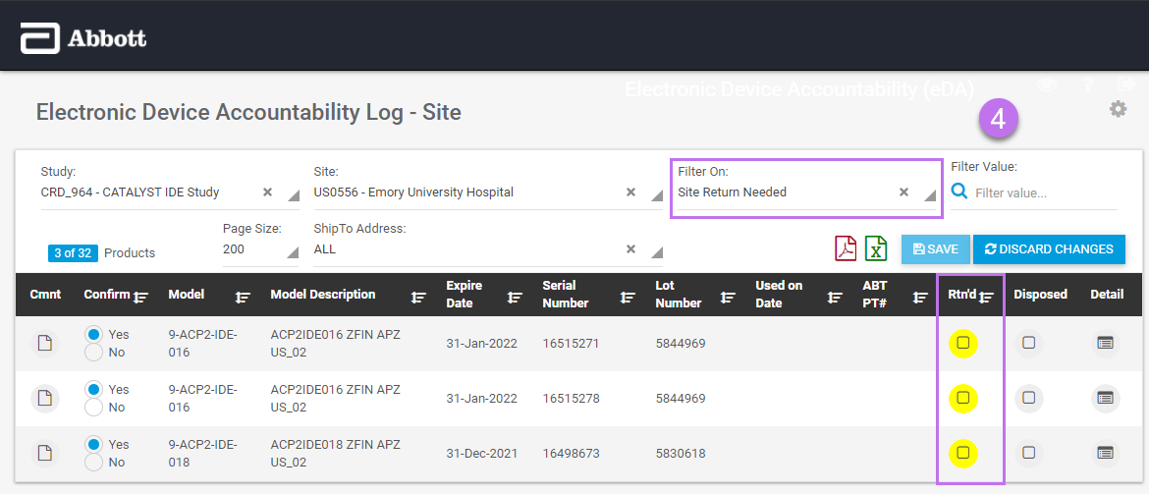
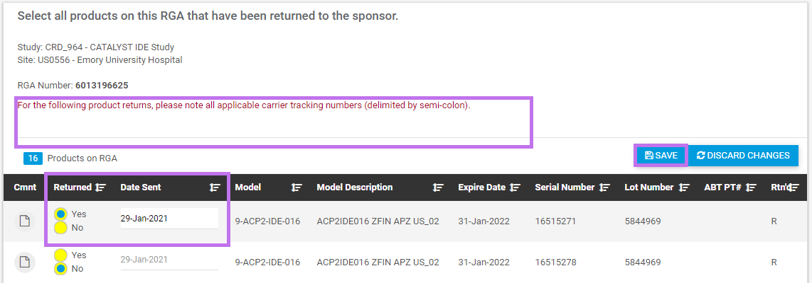
* NOTE: All eDA Log changes must be Saved or they will be lost.

E-Logs
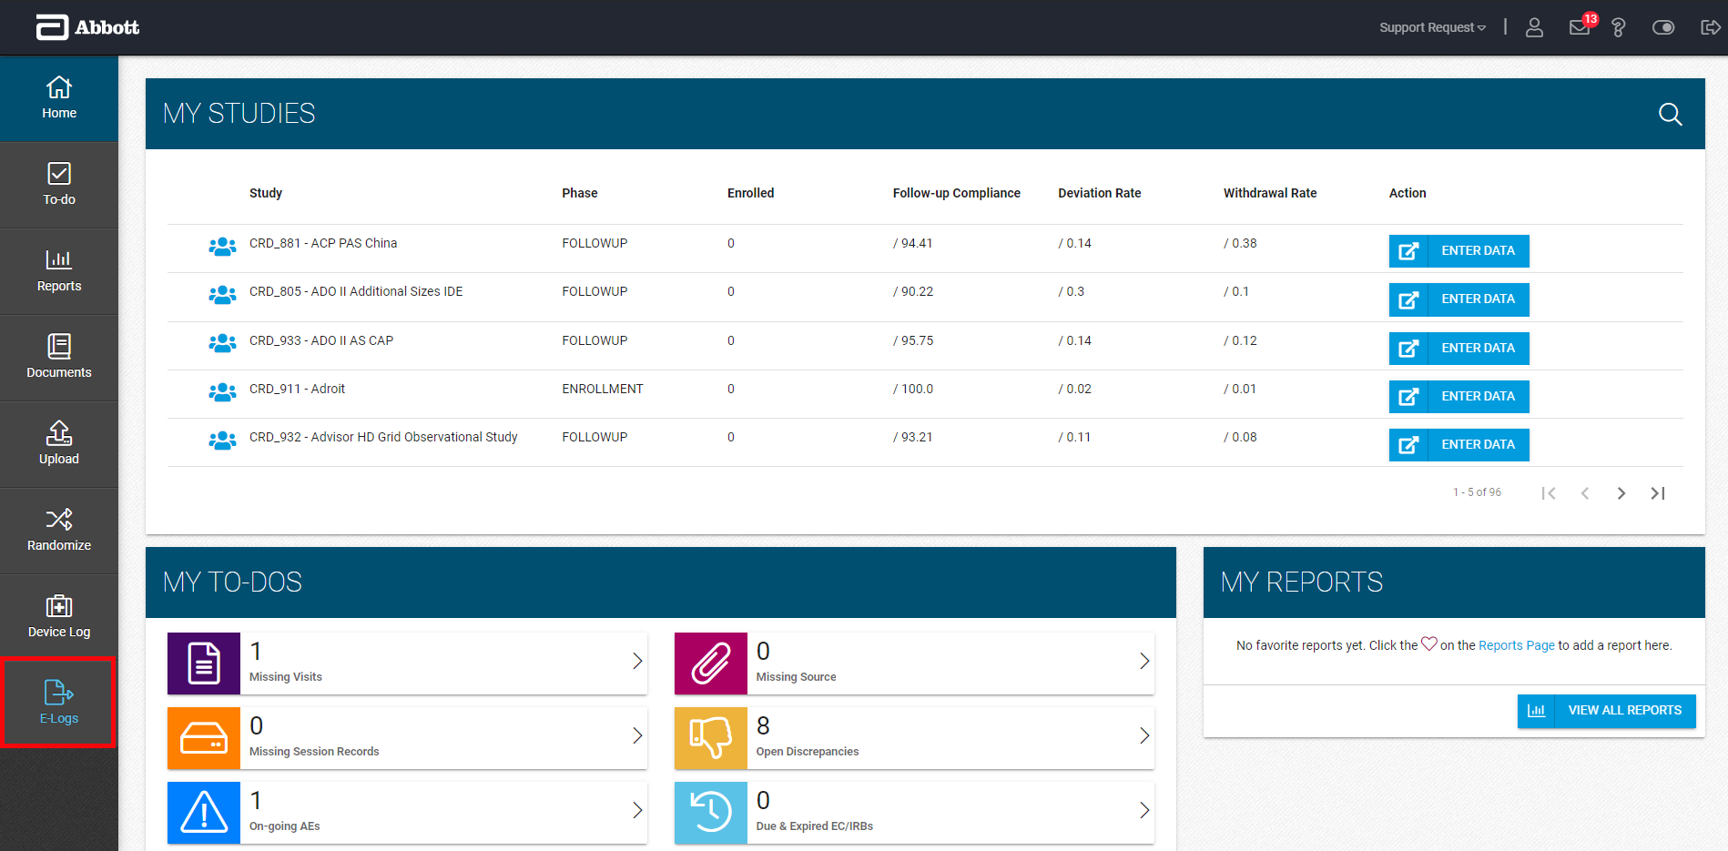
The E-Logs page will launch the Electronic Logs application. For studies using an electronic log, you will be able to update and sign appropriate log entries, when applicable.*
* Launch the application to see if you have any outstanding action items.

Dashboard
If any of your study-sites are listed in the Dashboard with a count in the Site Action Items column, click on the Launch () icon to access that study-site document.
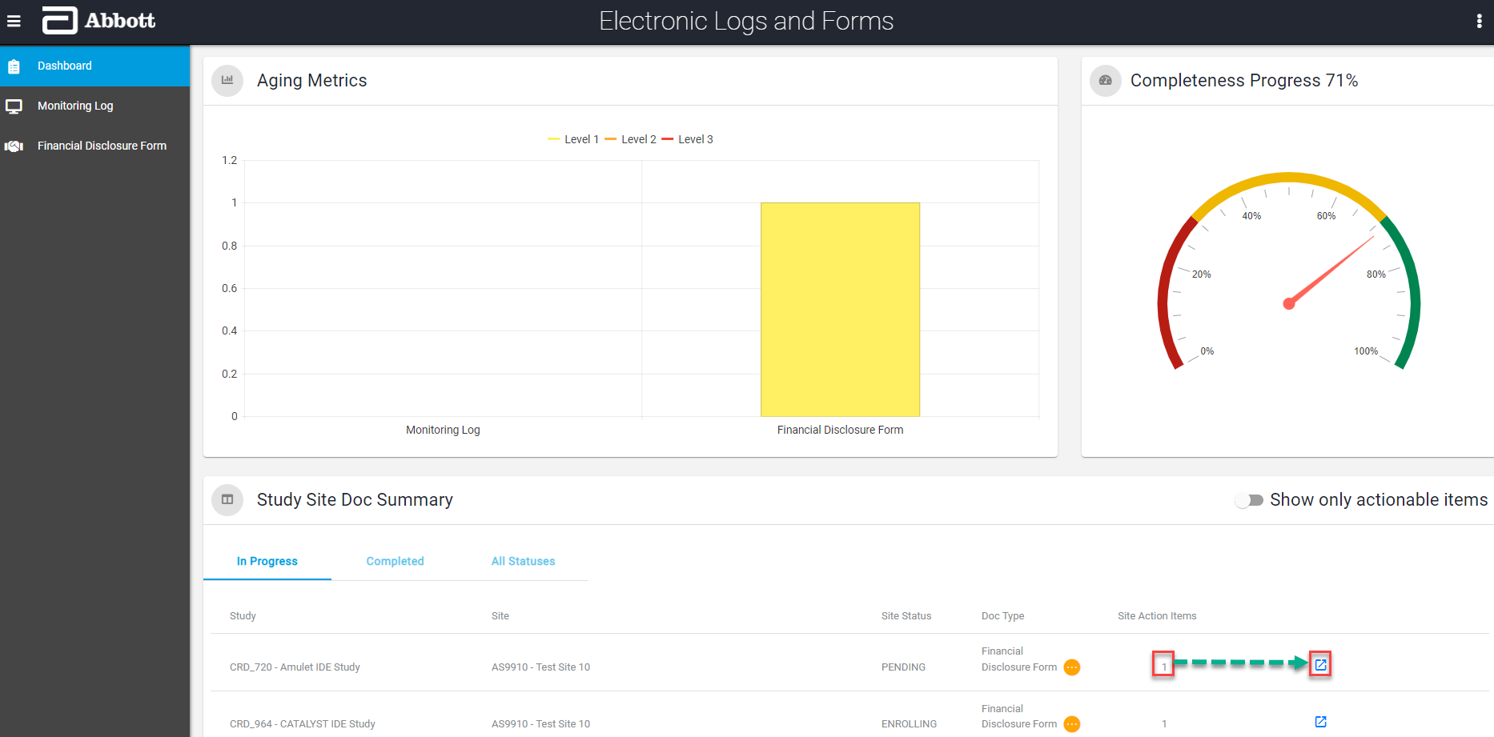
Monitoring Log
- Once the log launches for the selected study-site, you can sign each assigned entry by:
  - Clicking on your name link
  - Clicking on the options () icon and then selecting Site Sign
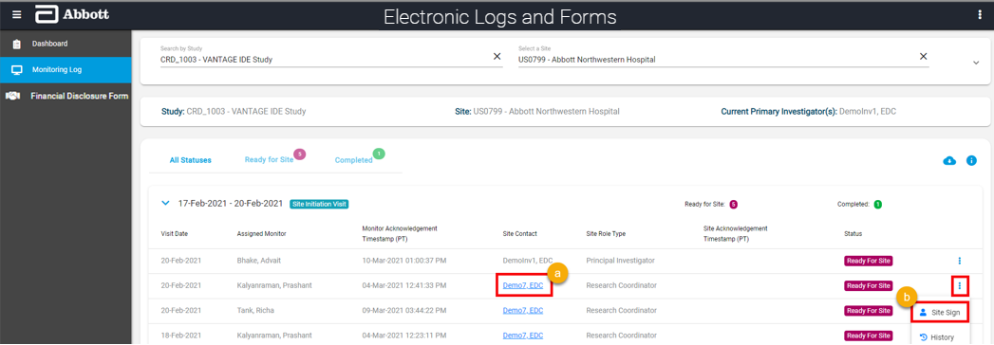
- Enter your Abbott EDC Study Portal User Name and Password, and then click Submit.
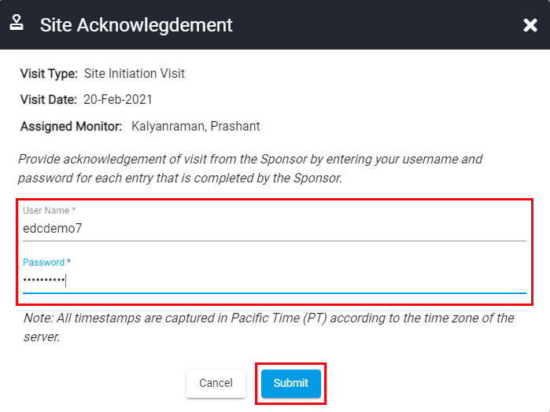
- The log entry will be updated to display the timestamp* of your acknowledgment and Completed status.
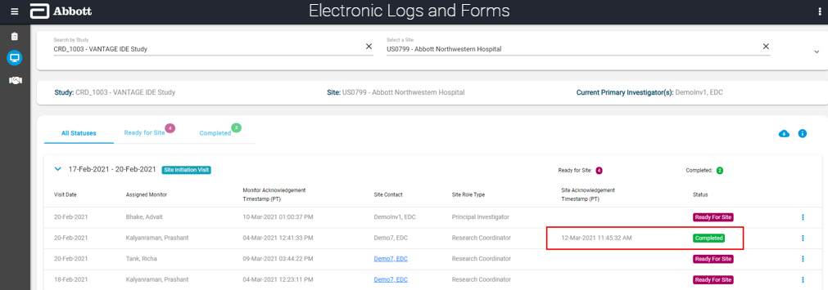
* All timestamps will display in Pacific Time (PT), the time zone of the server.
Financial Disclosure Form
- Click on the options () icon for the Timepoint you want and select “Create Form” to enter and submit a new form or “Edit Form” to edit and re-submit an existing form.
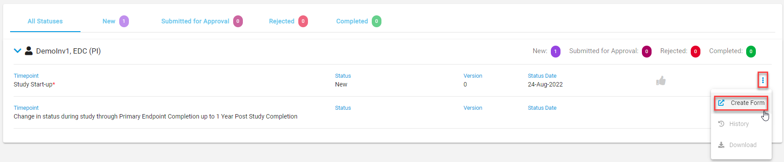
- The Financial Disclosure Form launches, and you can either select the thumbs up (agreement) or thumbs down (disagreement)* icon for each statement on the form.
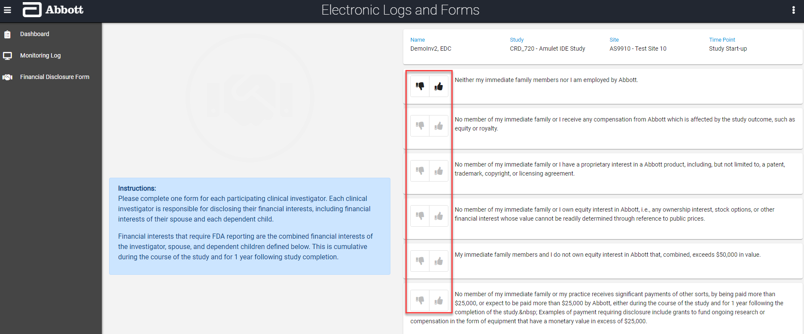
*An explanation will be required for each disagreement.
- Once you are done choosing an answer for all six statements on the form, you will enter your Abbott EDC Study Portal Username and Password, and then click Sign Financial Disclosure.
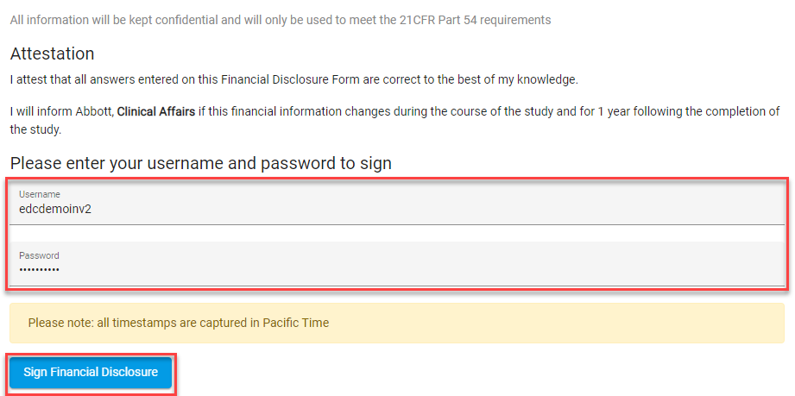
- Once you complete and sign the form, a confirmation message will pop up that says “Your form has been submitted. Click here to go to Financial Disclosures.”
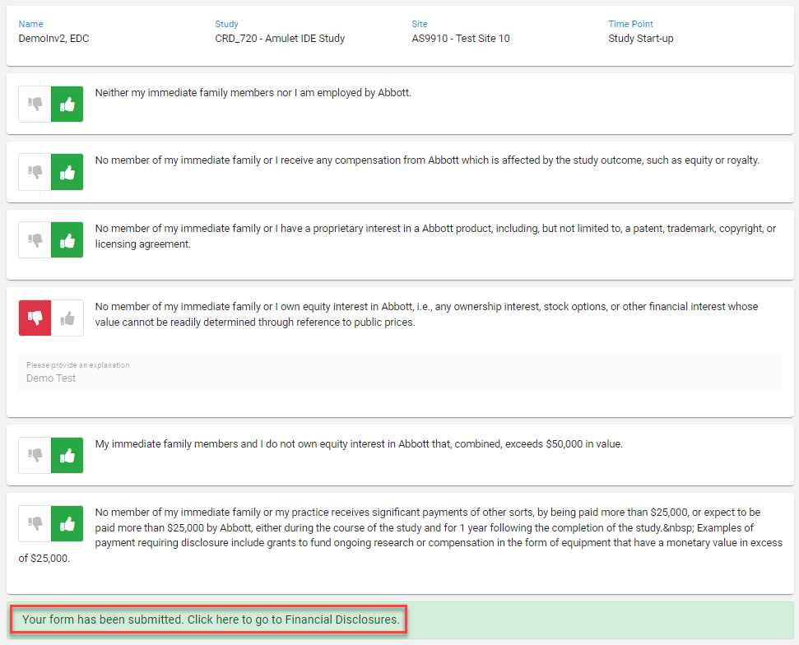
- When you click on the confirmation message in the screenshot above, the application will take you back to the Financial Disclosures page where you can see your submission* and now have the option to “Edit Form” if you need to submit a change to the form.
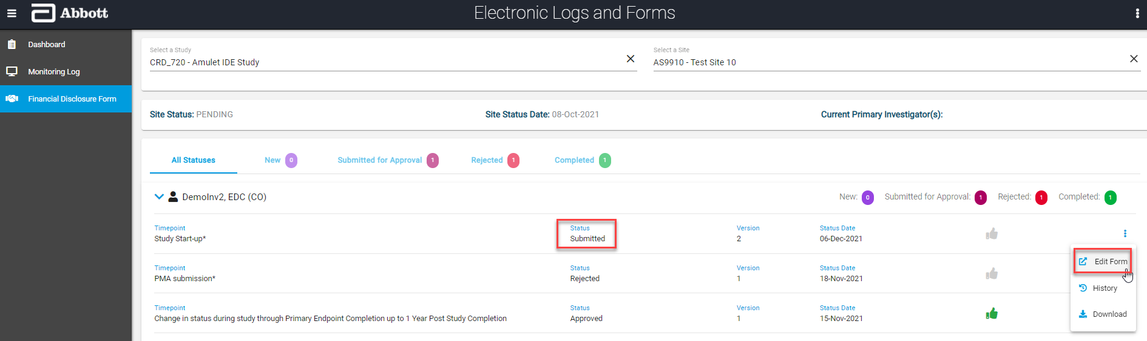
* All timestamps will be stored in Pacific Time (PT), the time zone of the server.

